1. What does the dollar($) sign do?

Ans

An absolute reference in Excel is a cell address with the dollar sign ($) in the row or column coordinates, like $A$1. The dollar sign **fixes the reference to a given cell, so that it remains unchanged no matter where the formula moves**.

In other words, using $ in cell references allows you to copy the formula in Excel without changing references.

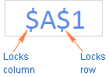

For example, if you have 10 in cell A1 and you use an **absolute cell reference** ($A$1), the formula **=$A$1+5** will always return 15, no matter what other cells that formula is copied to. On the other hand, if you write the same formula with a **relative cell reference** (A1), and then copy it down to other cells in the column, a different value will be calculated for each row. The following image demonstrates the difference:  
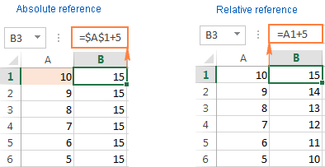

1. How to Change the Reference from Relative to Absolute (or Mixed)?

Ans

a cell reference is a relative reference, which means that the reference is relative to the location of the cell. If, for example, you refer to cell A2 from cell C2, you are actually referring to a cell that is two columns to the left (C minus A)—in the same row (2). When you copy a formula that contains a relative cell reference, that reference in the formula will change.

As an example, if you copy the formula **=B4*C4** from cell D4 to D5, the formula in D5 adjusts to the right by one column and becomes **=B5*C5**. If you want to maintain the original cell reference in this example when you copy it, you make the cell reference absolute by preceding the columns (B and C) and row (2) with a dollar sign (**$**). Then, when you copy the formula **=$B$4*$C$4** from D4 to D5, the formula stays exactly the same.

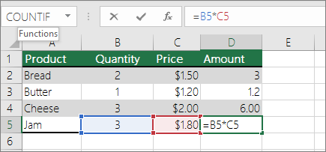

Less often, you may want to mixed absolute and relative cell references by preceding either the column or the row value with a dollar sign—which fixes either the column or the row (for example, $B4 or C$4).

To change the type of cell reference:

1. Select the cell that contains the formula.
2. In the formula bar utton image, select the reference that you want to change.
3. Press F4 to switch between the reference types.

The table below summarizes how a reference type updates if a formula containing the reference is copied two cells down and two cells to the right.

| **For a formula being copied:** | **If the reference is:** | **It changes to:** |
| --- | --- | --- |
| ormula being copied from A1, to two cells down and to the right | $A$1 (absolute column and absolute row) | $A$1 (the reference is absolute) |
|  | A$1 (relative column and absolute row) | C$1 (the reference is mixed) |
|  | $A1 (absolute column and relative row) | $A3 (the reference is mixed) |
|  | A1 (relative column and relative row) | C3 (the reference is relative) |

1. Explain the order of operations in excel?

Ans

When evaluating a formula, Excel follows a standard math protocol called "order of operations". In general, Excel's order of operation follows the acronym PEMDAS (**Parentheses, Exponents, Multiplication, Division, Addition, Subtraction**) but with some customization to handle the formula syntax in a spreadsheet.

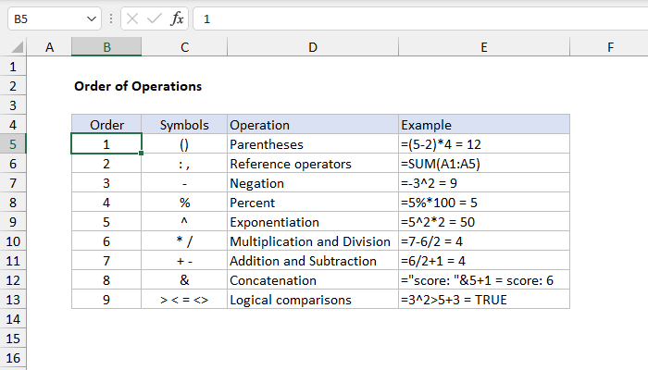

4. What, according to you, are the top 5 functions in excel and write a basic syntax

for any of two?

Ans

**1. The SUM Function**

The *sum* function is the most used function when it comes to computing data on Excel. This function works to sum a group of numbers in a specific set of cells. This means you don’t need to type a long cumbrous formula just to calculate the sum of all the data you need. Because of its popularity, newer versions of Microsoft Excel have a button specifically for this function.

## 2. The TEXT Function

Text function is a useful tool that helps convert a date (or number) into a text string in a particular format. It falls in the category of string formulas that converts numerical values to a string. It is handy when users need to view numeric data in a readable format. Take note that the “TEXT” formula only works to convert numeric values to text. Therefore, its results cannot be calculated.

**3. The VLOOKUP Function**

*VLookup* is powerful Excel function that is often overlooked. Users will find it useful when they need to find specific data on a large table. You can also use *VLookup*to search for names, phone number, or specific data on your sheet. Instead of manually looking for the names and wasting time scrolling through hundreds of data, the [*VLookup* function](http://spreadsheeto.com/vlookup/) makes this process faster and more efficient.

**4. The AVERAGE Function**

The *average* function is an extremely useful tool for getting the average value in a range of cells. Like the *sum*function, it is frequently used in computing and analyzing data on spreadsheet. Basically, the *average* function works to find the “arithmetic mean” for a group of cells. Aside from the *average* function, Excel also has the *median* and *mode* function.

## 5. The CONCATENATE Function

This function is a good time saver when you need to combine data from 2 or more cells. Unlike the merge tool which physically merges two or more cells into a single cell, the concatenate function only combines the contents of the combined cells. In the latest version of Excel ( 2016), the concatenate function has been replaced with concat function and will be incorporated in more future versions of Excel.

1. When would you use the subtotal function?

Ans

Use these constants **when you want to subtotal only nonhidden numbers in a list**. The SUBTOTAL function ignores any rows that are not included in the result of a filter, no matter which function_num value you use. The SUBTOTAL function is designed for columns of data, or vertical ranges.

6. What is the syntax of the vlookup function? Explain the terms in it?

Ans

In its simplest form, the VLOOKUP function says: =VLOOKUP(What you want to look up, where you want to look for it, the column number in the range containing the value to return, return an Approximate or Exact match – indicated as 1/TRUE, or 0/FALSE).